### **Website Overview: Building a Small Business**

I had the opportunity this fall 2019 semester to work with my friend and co-worker, Artesia Saxton, to help create a newsletter and website for her husband Vince Ziegler’s small business, [**Snowline Transportation, LLC**](https://snowlinetransportation.wordpress.com/). A relatively new business, they did not have a newsletter, Facebook page, or a general website for use. Having never ventured into a project like this one, I learned several lessons along the way about what specific details help to personalize a company’s website – and the thought processes behind it. I learned more about the value of setting daily and weekly goals, and the importance of patience. Work like this is very detail-oriented, which played well to my strengths regarding planning and organization. I also enjoyed the levels of originality that accompanied this ongoing project – and was given much freedom to invest into my various ideas along the way, which I greatly appreciated.

Please find below a brief timeline of various work done for Snowline. There were several small changes made along the way while building, but I have tried my absolute best to record all of the important details during the last four months of diligent work. I was sure to include some of the first screenshots I made after initially building the site, and a few others as well, to show its steady progression. I have also discussed the overall results, and general effectiveness of the usability testing.

### **A Brief Timeline of the Work Done for Snowline Transportation, LLC**

**September 26th–October 20th:**

* Permission acquired to begin work on a new newsletter and website for a small business from company owners Vince Ziegler and Artesia Saxton in late September.
* Introductory email about primary website goals, i.e.: collecting necessary contact information, company address, their unique mission statement, services they offer, etc. Website samples of some of my previous work sent to Artesia via email.
* Website created on *WordPress.com,* began with minimal information given.
* New account for business page set up, including new Hotmail account to access it.
* Theme page, fonts, and the original color scheme created.
* Created title banners, “Mission Statement,” and “What We Do.”
* Created company tagline: “There’s No Business Like Snow Business.”
* Created some separate business pages for the header menu: “Home,” “Meet Our Team,” “Our Accomplishments,” “Upcoming Events,” and “What Others Say.”
* Misc. Website homepage site building:
* Added in an “Our Services” section.
* New image added to “Our Services” section after Snowline truck images acquired.
* Added “call for free quote!” text, phone number, and “or contact our mail business office by mail” information.
* Added Snowline’s warehouse hours, warehouse locator map, “Family owned and operated since 2016” tag, and company copyrights in footer.
* Updated header sizes, and removed any existing images in the original default template.
* Updated “Plane” template from basic blue header, to bright blue cloud header.
* Added blue cloud title banners for each title section to match the updated main header.
* Given information for “Upcoming Events,” created another new page.
* Dates and location obtained for *Now Hiring* and *Turkey Drop* Events. Waiting on *Toy Drive* information at this time.
* *Please note*: I was not given images to use for the two holiday events; as there were not any available. Checked back with Artesia in early November regarding this.

**Summary and Estimated Hours Spent (First Half):**

**3 weeks + 4 additional days – 3-4 hours, daily.** The extra hours are accounted to additional in-person meetings with Artesia to discuss what elements she and Vince wanted to possibly include, deciding which website builder to use and exploring other options via research, and the initial setup for a new *WordPress.com* account; all whist getting familiar with it, (business pages are slightly different than blogs). I also opted to do weekly check-in updates with Artesia and Vince via email and text every Friday since the start of the project(s) to gage my progress, and to exchange further ideas.

**October 20th–November 10th:**

* Ditched idea for an “Our Accomplishments” page – never received any updated information.
* Focused on “What Others Say” idea instead, and requested quotes via email.
* Told to put “Accomplishments” page back, and that “we can fill those in later.” Left page blank for future use.
* Wanted to also use testimonials idea for Newsletter, pitched the idea.
* Pitched another idea for a possible “family album” page. Never got the green light.
* Acquired new email from Vince with Excel file for a “What Others Say” page.
* Re-used blank “Our Accomplishments” page for updated “Testimonials,” instead.
* Was told to select 3-4 positive quotes from a various selection for the newsletter and website. Was not given any names for the quotes in time to include on newsletter draft, (due 10/24/19).
* Received another email for update testimonials page/newsletter with names for quotes. Prompted updated newsletter and for the website’s “testimonials” page.
* Emailed current hiring credentials for a requested “Now Hiring” page.
* Created the “Now Hiring” page.
* Added two forms “Contact Us” and “Send Us an Email.”
* Linked addresses to google maps.
* Added warehouse image and tagline for image.
* Added another title banner, job information, hiring “Responsibilities” and “Qualifications.”
* Added “also apply on Indeed.com” button, with an outgoing link.
* Emailed photograph samples and additional information for Vince to use for “Meet Our Team” page, updated the website.
* Waiting at this time for photographs, quotes, emails, and phone numbers for two additional team members, Rose and Derrhun Whitten.
* Added a “Think You’ve Got What It Takes? Join Our Team!” title banner, and “Now Hiring” button/link. Changed “Now Hiring” button color to blue, linked to updated “Now Hiring” page.

**Summary and Estimated Hours Spent (Second Half):**

**3 weeks** **– 2-3 hours, daily.** Sent three additional emails along with my usual Friday check-in to Artesia this quarter to show new screenshots of my current progress, and two separate word document listings I put together of items I still needed to update the website.

It was also starting to become difficult to keep in contact with her and Vince, because he was scheduled for shoulder surgery, and Artesia was on family leave.

**November 10th–December 4th:**

* Given the rest of the additional information for “Updated Events” page.
* Made updates to the page throughout the semester, to reflect changing dates.
* Changed the header title and opening paragraph to reflect these changes.
* Updated first image for *Now Hiring* event; left the two others as is.
* *Please note*: emailed several times about updating images for the two holiday related events, was informed that Vince liked the free-to-use images I used of the Thanksgiving turkey and holiday toy truck.
* Emailed missing photos and information for “Meet Our Team” page.
* Artesia replaced Rose Whitten. Profiles updated to include missing information.
* Fixed grammar issues with original quotes sent over by Artesia.
* Saved and re-sized the two new photographs given, to match Vince’s.
* Updated incorrect phone numbers originally received.
* Updated all of the job titles for the team members, per Artesia’s request.
* Created a new “Our FAQ’s” page to replace another un-used “Accomplishments” page.
* Sent email to Artesia asking about which questions to include for the FAQ.
* Given permission to use the questions I opted to draft to her, via email.
* Added in the FAQs, links to other homepages, email title banner and form, changed “submit” button to light blue.
* Updated page to include Artesia’s photo, and a new greeting quote from her.

**(Thanksgiving Break – No Website Updates Made through November 25–29th).**

* Made some final adjustments to entire website before launch date on December 4th.
* Added licensing information per Professor Perkins’ suggestion, to the website footer.
* Added Vince’s photo, and a greeting quote from him to the “Testimonials” page.
* Cleaned up email forms by deleting unwanted content, leveled out title banners, adjusted font sizes, bolding, etc. Added website design credit to website footer.
* Shifted things around on main “Home” page to prevent excessive scrolling.
* Added in alt text for every photograph in media folder, and on each individual page.

**Summary and Estimated Hours Spent (Last Half):**

**3 weeks + 3 additional days – 2–3 hours, daily (first two weeks), 3+ hours (last week, final days).** Sent several reminder emails and texts for information still needed. Overall communication was severely lacking by this point, though my emails continued. Nearing wrap-up, I continued to receive creative freedom to make as many changes and improvements as I desired, which was appreciated.

### **Screenshots: Building a New Home for Snowline Transportation, LLC**

Below are the **first** screenshots of my progress on **each page** of the site to give you an idea of the differences. I kept original wording for some areas. Forgive the small text, (I wanted to capture the entire page), and *please ignore the black bars on some screenshots.* **Page 4** **is version 1** **of “Home.”**

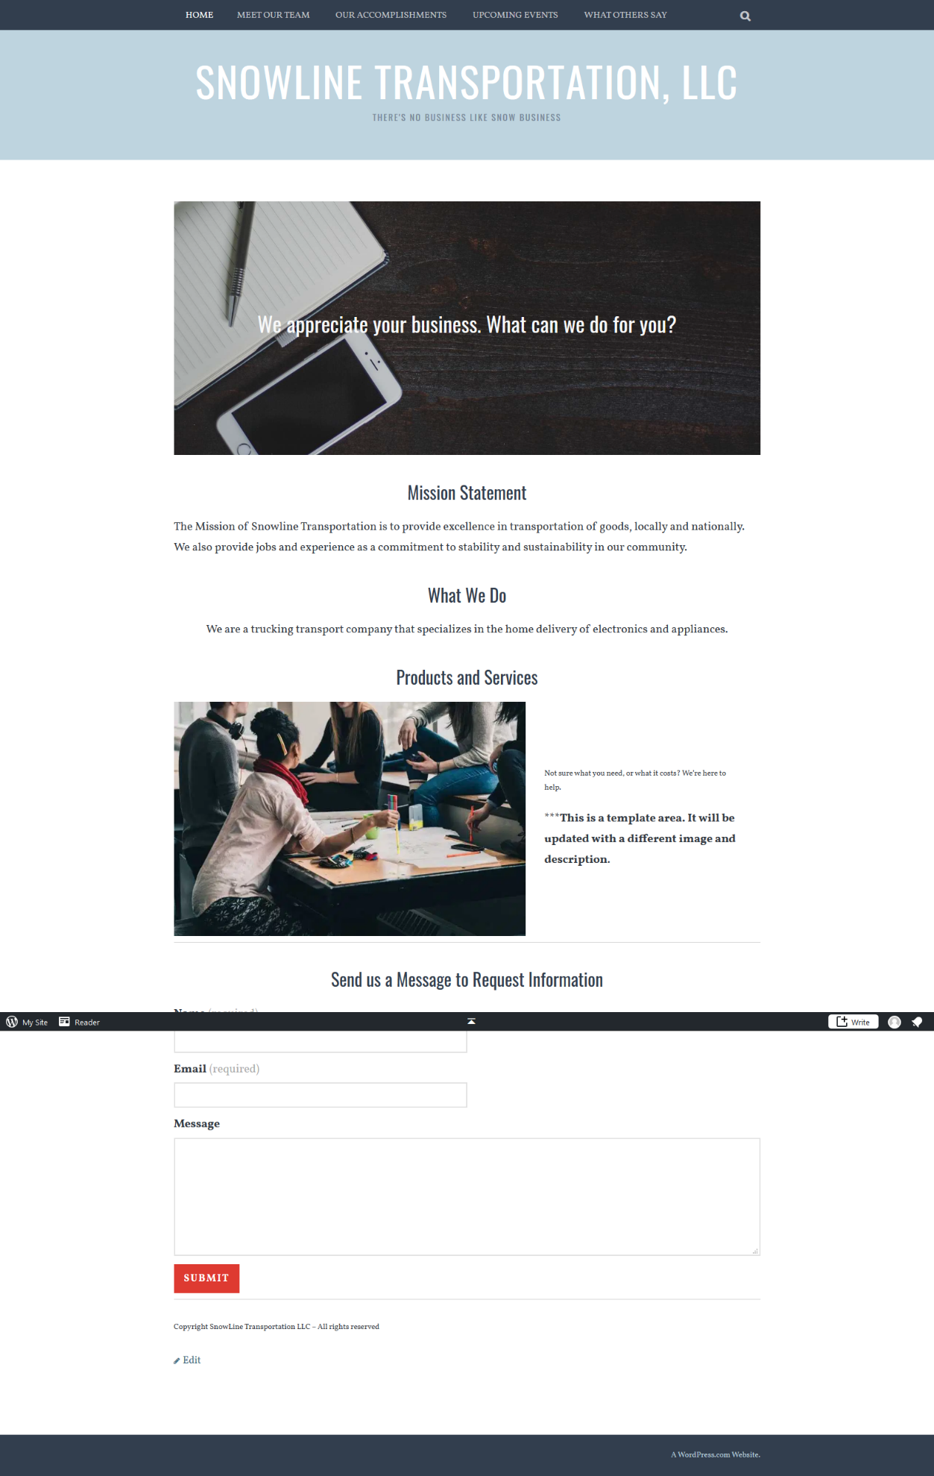

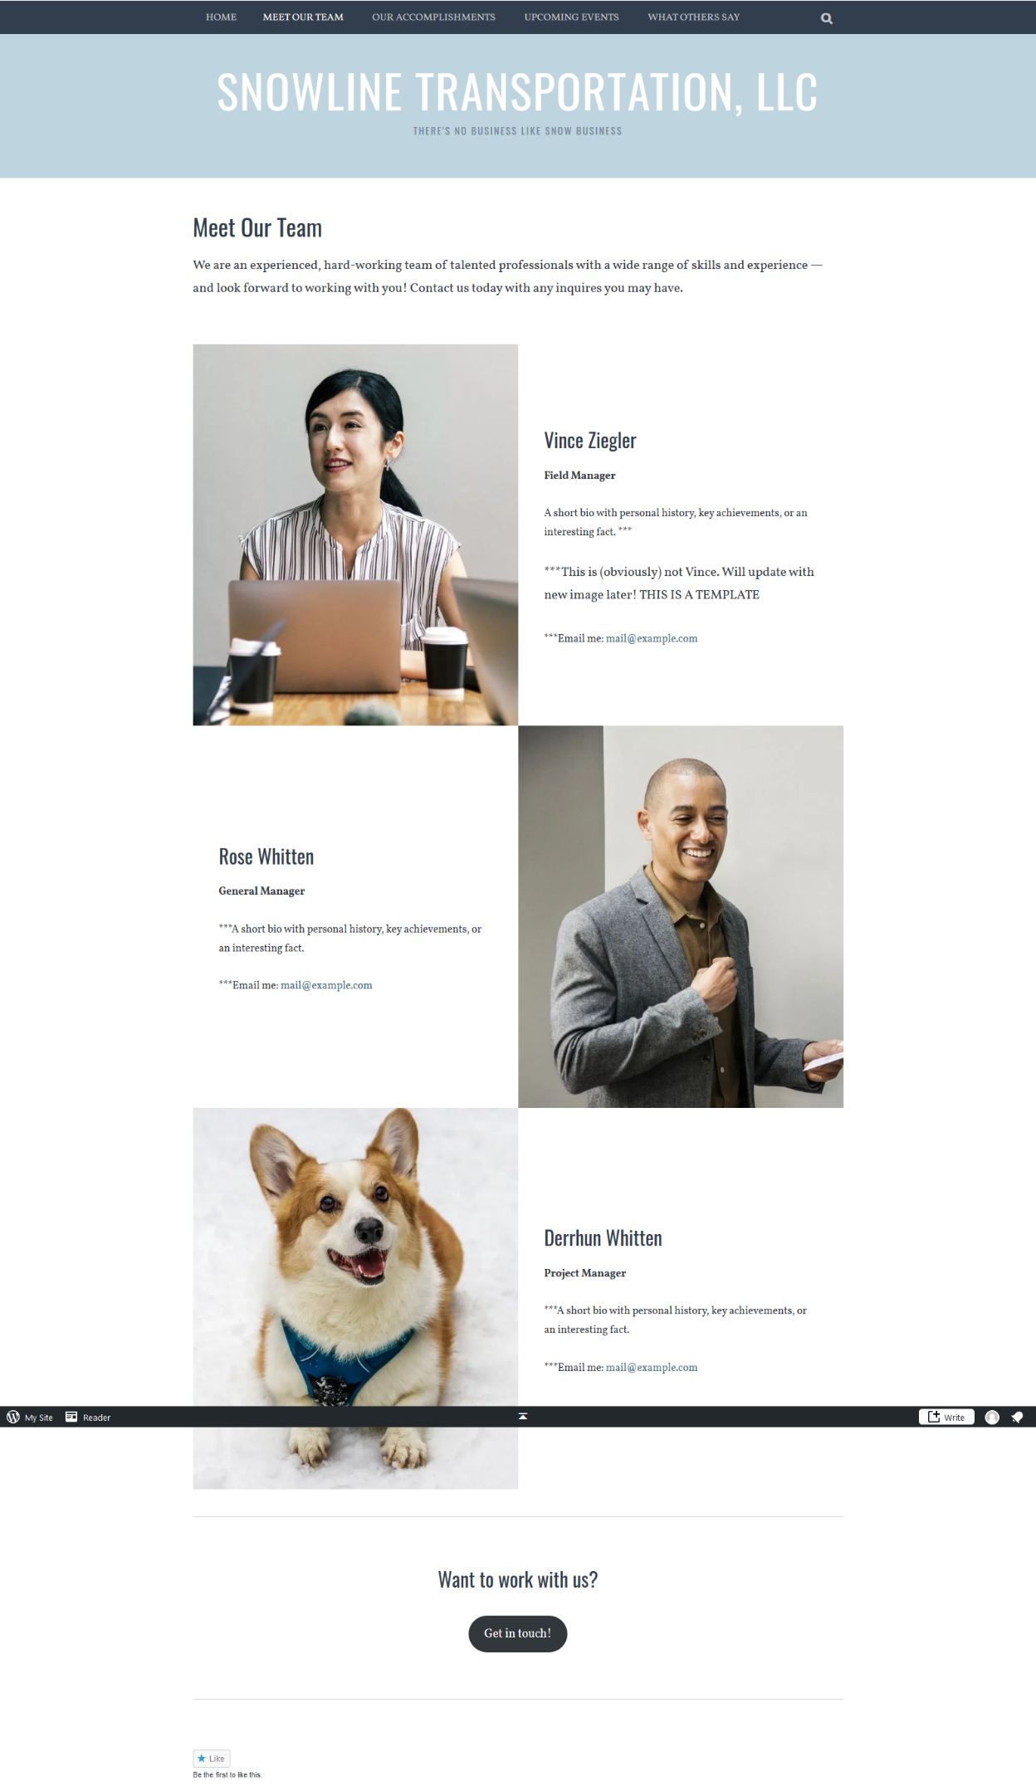

**Previous: see page 5 for Version 1 of “Meet Our Team.”** – the corgi template photo made everyone laugh for weeks when I “previewed” the site, before I *finally* updated the info in mid-November!

**Screenshot below of the first and original “Our Accomplishments” page**, posted as an example template, to suggest ideas, which eventually got scrapped, and replaced by current “Testimonials” page.

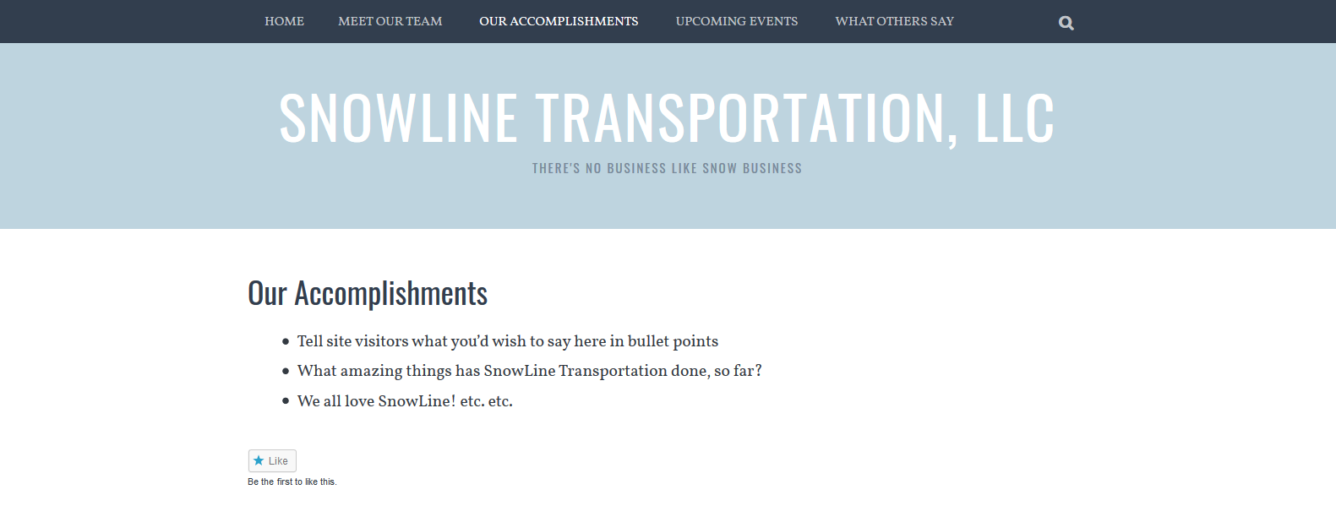

**Screenshots below of version 1 of “Upcoming Events” and “What Others Say” pages.** Completely empty to start, the events page will get an overall, and the other will be replaced by the FAQ’s page.

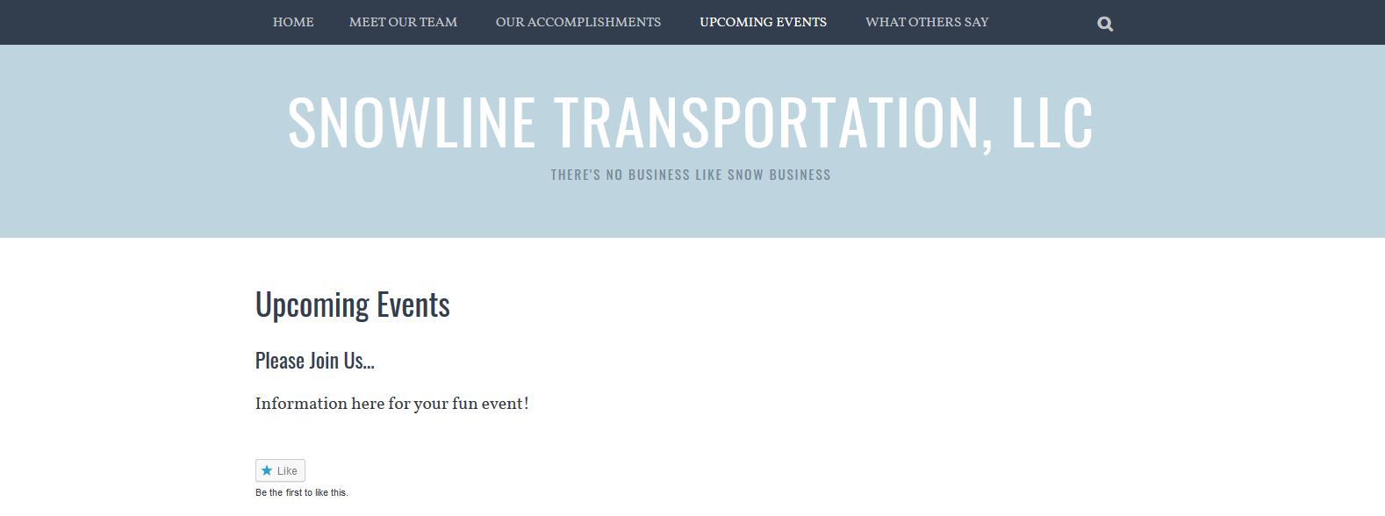

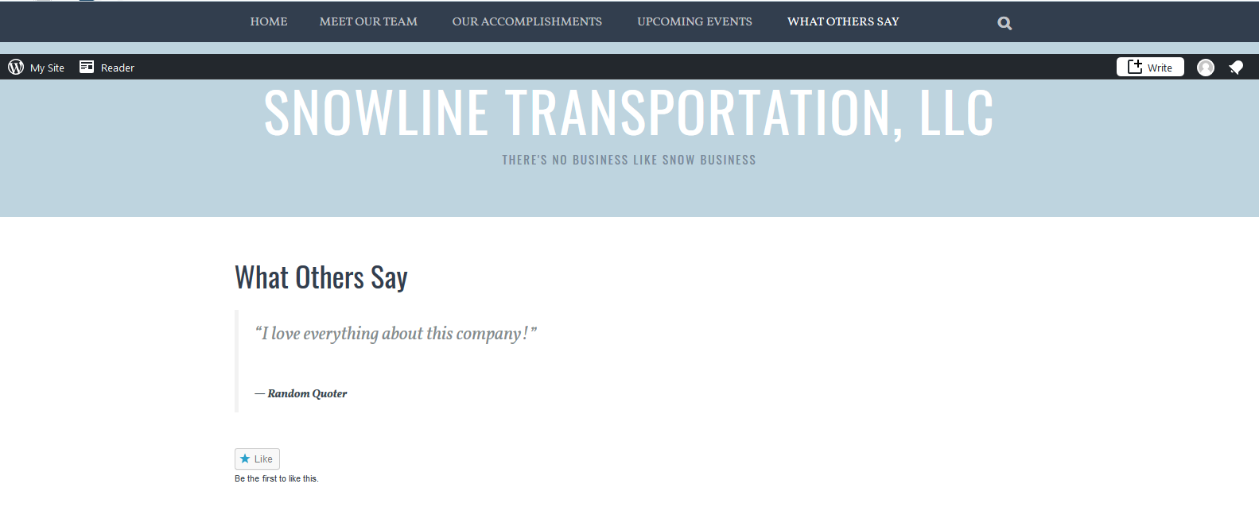

This particular set of screenshots on the next few pages are **different examples of a few more of the changes I made to each page**, throughout the course of the semester.

I added in a **new “Now Hiring” page**, prompted by the addition of the “Think You’ve Got What It Takes? Join Our Team!”Banner **|** Now Hiring button, on the “Meet Our Team” page.

It also underwent some relevant changes along the way. I updated the image of the truck to the warehouse items/tagline “Delivering quality goods to suit your needs,” modified the “additional queries” paragraph, added in the current “Looking to Hire…” banner, and additional “Responsibilities” and “Qualifications” information I was given from their now hiring ad on *Indeed.com;* along with an easy to find “also apply on Indeed.com” button, in the newest version before usability testing.

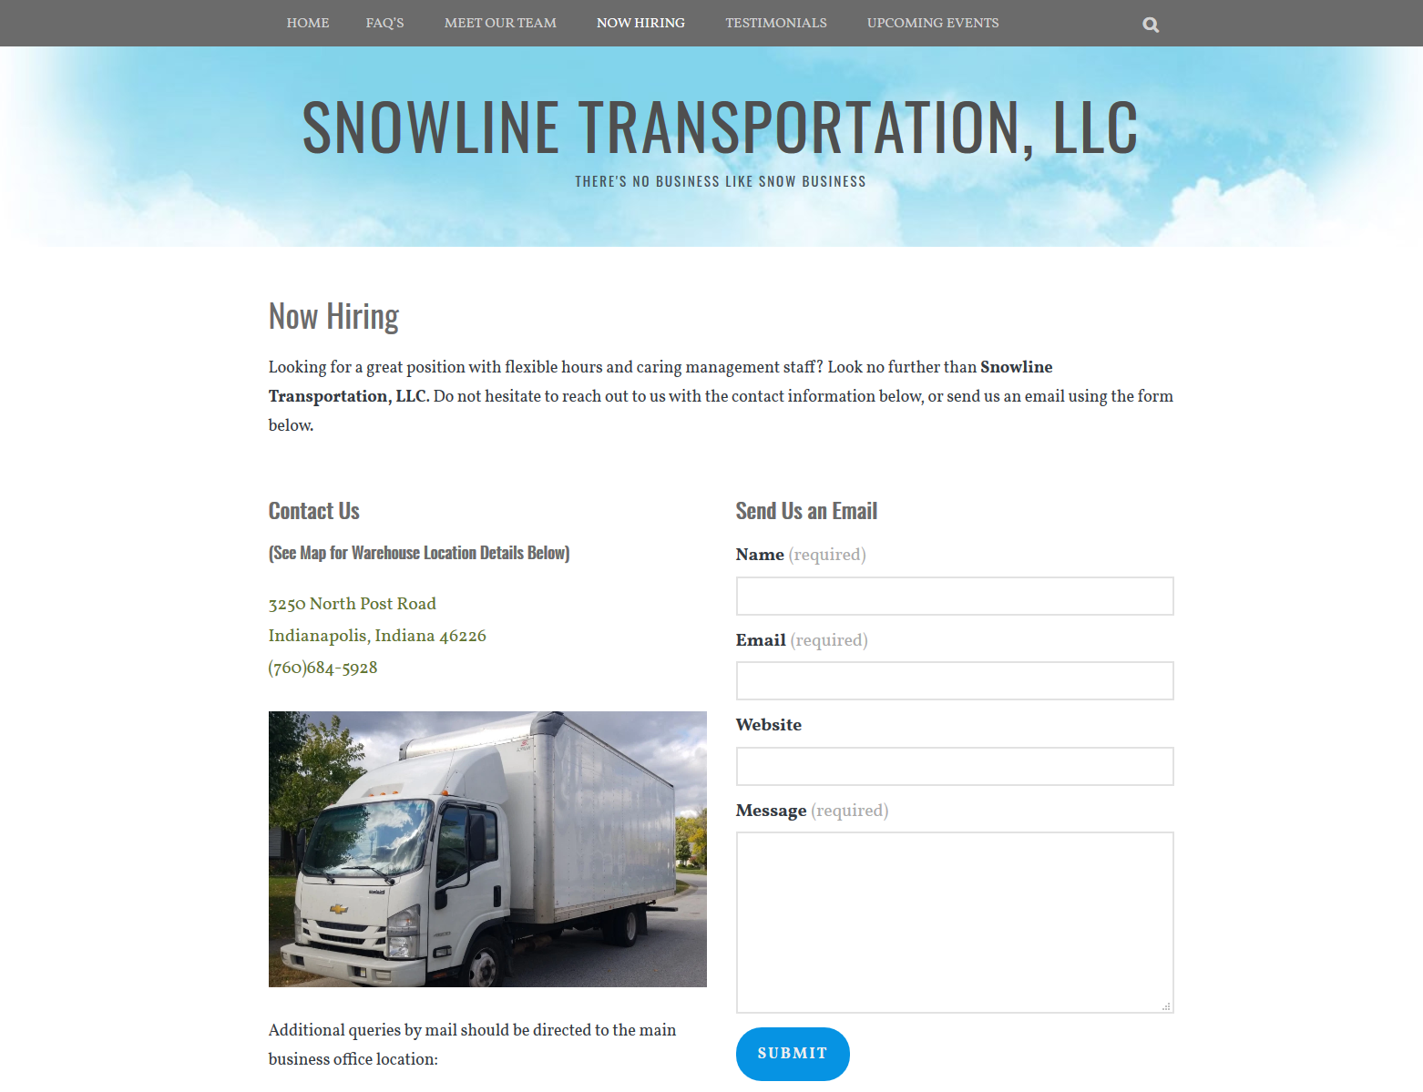

By late October – I was still waiting on the additional information to add for the modified **“Meet Our Team” page**, but opted to email Artesia and Vince another screenshot to display what I currently had, and what I still needed from them.

At this time, Rose Whitten was still listed as a team member, but this would also ultimately change in the newest version before usability testing, per Artesia’s instructions. **See page 8 for Version 2 of “Meet Our Team.”** Artesia had also decided at this time to use quotes for the team and not mini-biographies.

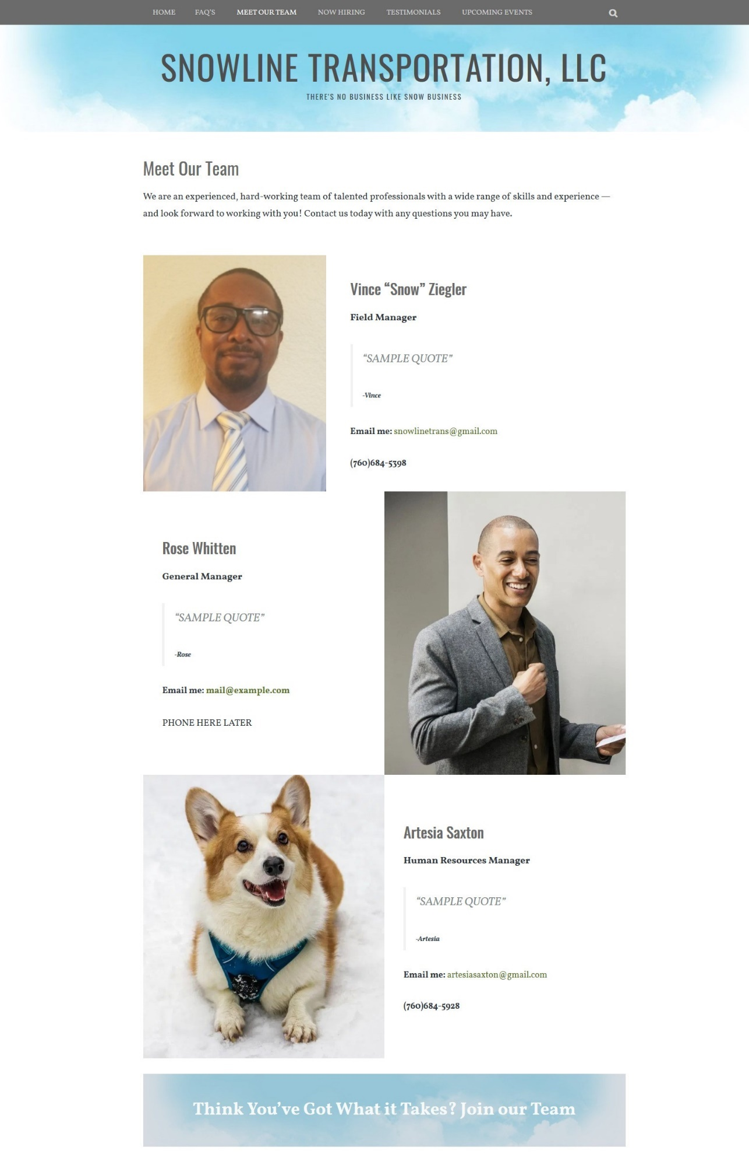

**The “Upcoming Events” page** underwent a few modifications towards the newest version (There were 3-4 different versions), **version 3 is showcased below**. I opted to showcase the company’s past events, as I knew by the time the site went live for usability testing, (December 4-5th), the events would be passed. However, I *still* wanted others to know of them – since these are ongoing, and hosted annually by Snowline Transportation, LLC throughout the year.

I added the October hiring event as well on the finalized site, along with additional information included for each event, the blue stylized banners, and changed the wording in the paragraph and title header leading into the event. *Again, please disregard the black bar that appears at the bottom.* My screenshot feature in Firefox oftentimes did this, as I was creating full screen copies.

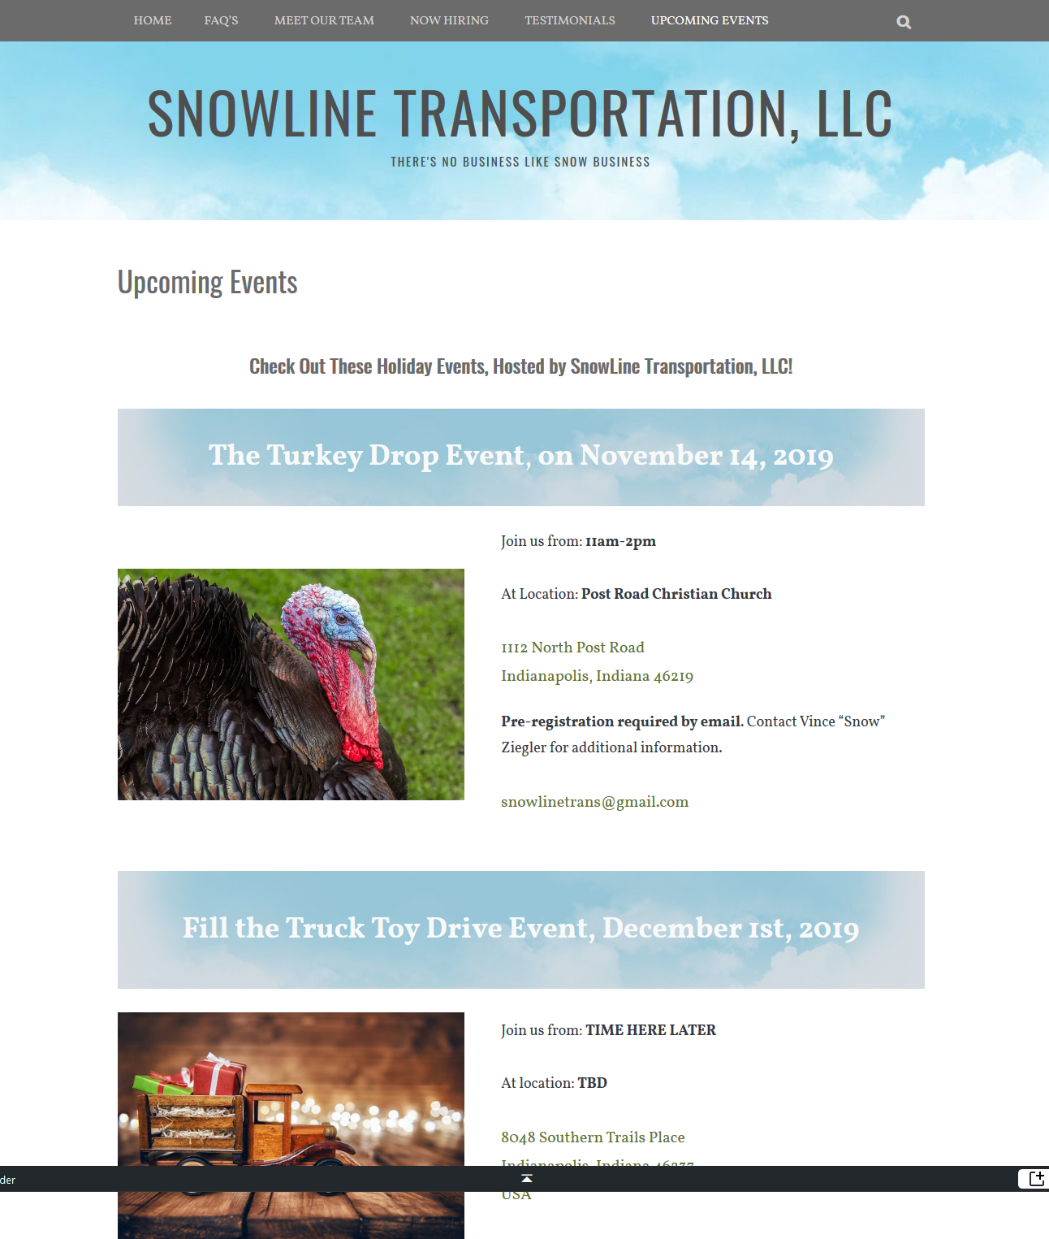

The two separate “Accomplishments” | “Our Accomplishments” pages underwent changes, as aforementioned. **The first template I created in version 1, on page 6** became the **“Testimonials” page**. The other that was eventually scrapped became the **“FAQ’s” | “Our FAQ’s,”** on the newest version.

*Please also note:* I changed the name of the newer page from “FAQ’s” to “Our FAQ’s” because I wanted it to show up in the *center* of the website’s primary menu header, to draw more attention to it.

**Below is version 2 of the newer Testimonials page.** In the last three-week quarter, I updated the fonts on the two secondary headers “Read what others say about our services!” and “Wish to share your positive experiences with us?” Also, in the final weeks, I opted to add more of a personalized touch, so I included Vince’s image (with his permission), and a quote at the top to help further endorse the testimonials in the newest version, presented for usability testing.

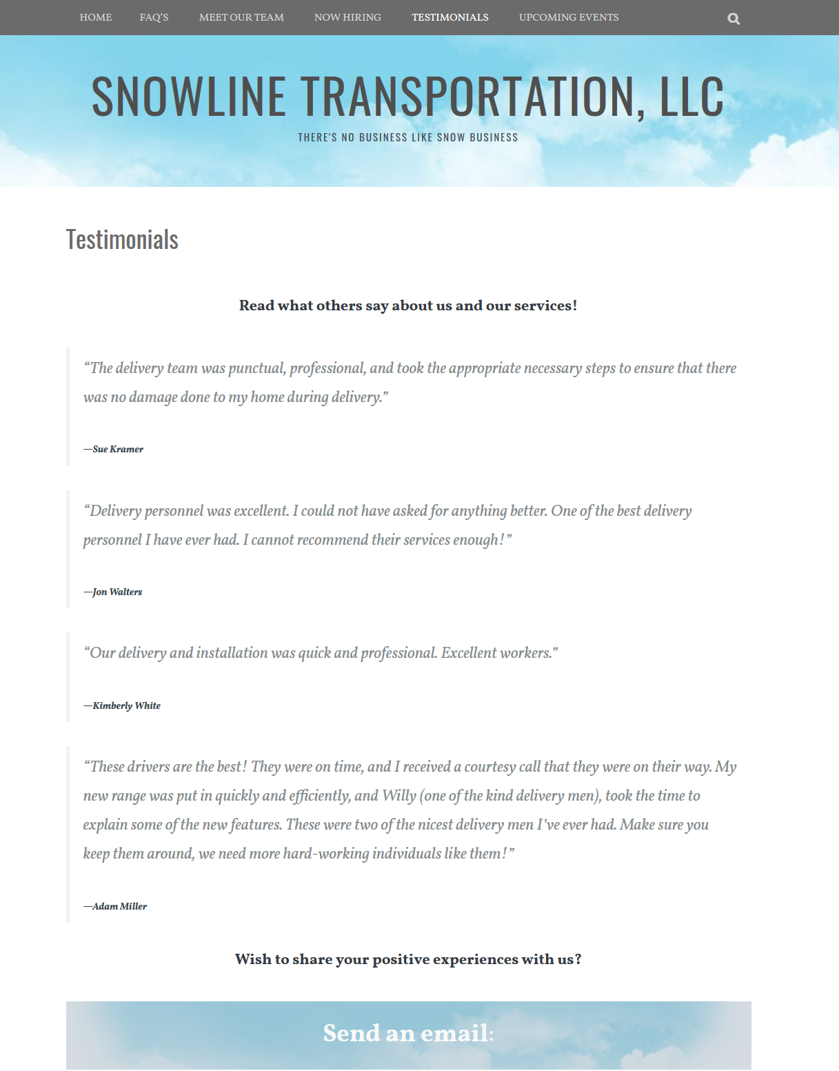

On this page, you will see **the first version of the “Our FAQ’s” page**, since it was a fairly recent addition, it did not undergo as many changes as did some of the other pages.

It simply replaced an unused “Accomplishments” page, and its name was changed from “FAQ” to “Our FAQ’s,” to make it a focal point. This time, I had opted to split the page into three different screenshots in the email I sent to Artesia, so she could read the text more closely, and make corrections. In **version 1 below**, I copied and pasted all of the information I had directly from the website at that point.

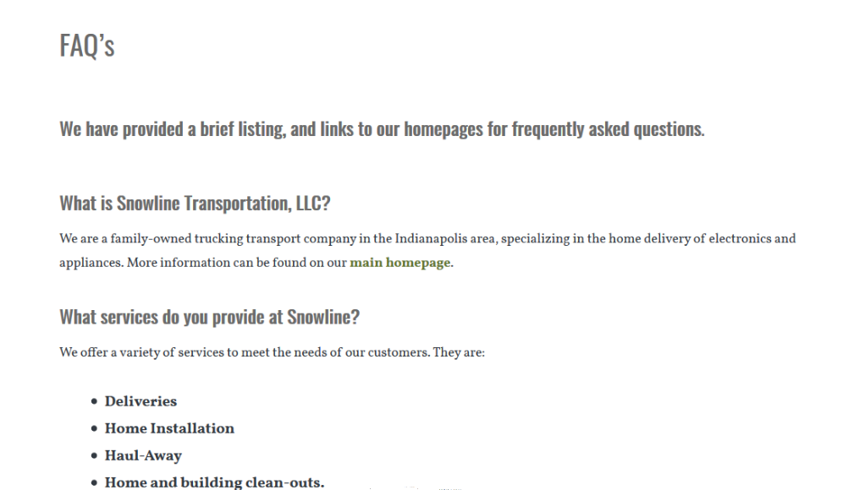

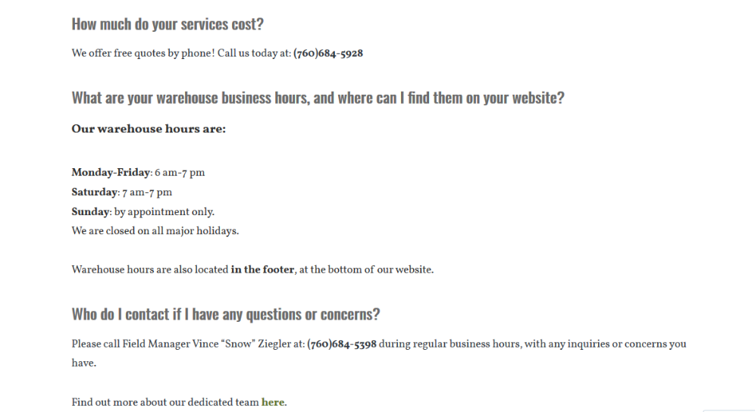

**Final screenshot for “FAQ’s | “Our FAQ’s” version 1, continued on page 12**.

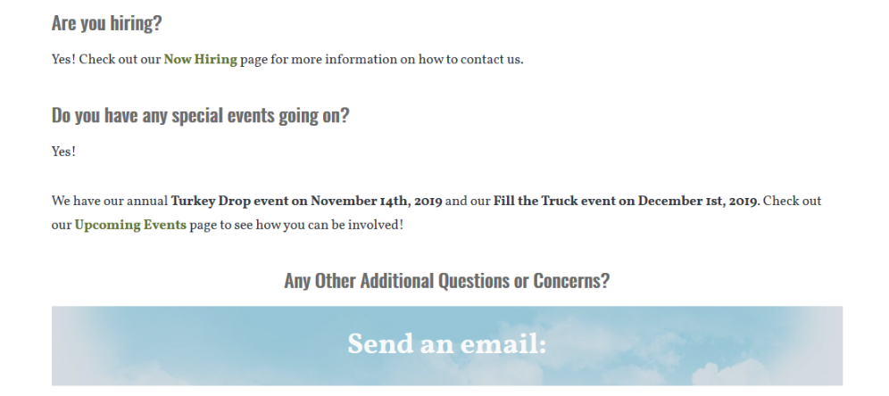

**The finalized version before usability testing began** would include the page’s name change, (Our FAQ’s), minor team corrections, updated phone numbers, a change in the “upcoming events,” along with one last invaluable question I overlooked in the first version, “where are you located?” I was pleased when Artesia gave permission to use her image and a positive quote to help further endorse the page, and give it a more personalized touch.

Finally, **the “home” page** was the trickiest, and also where I learned how to turn “cover pages” into colorful banners, and first made discovery that you can link all addresses to google maps, a feature I love! **Found on the following page, 13, is** **version 2 of the “home” page.**

Minor tweaks were continuously made: changes to the headers, some wording of the titles, i.e.: “Products and Services” in **version 1**, verses simply “Our Services” in the newest version, presented for usability testing. I added the new truck image, modified the email form, put in additional spacing between headers, so that everything was not bunched together and appeared more organized, the addition of “No Stamps? No Problem.” To correlate with the email prompt – and the most noticeable update in the newest version, the location of the “[Or] Contact Our Main Business Office by Mail.”

This gave me an issue, because while I had the paragraph and text centered under the simple “paragraph” block, (how *WordPress.com* is set up), it would not allow me to make the address contact information link to google maps, as it does with a separate “contact” block. I improvised, and added it to the previous block, so I could get it to link the address. I also updated the **website footer** to include additional information: licensing info, and new design credits. **Version 2 of the website footer is below**:

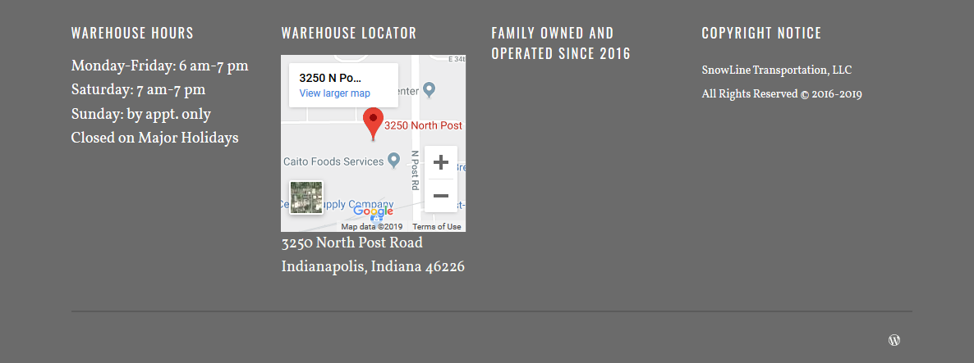

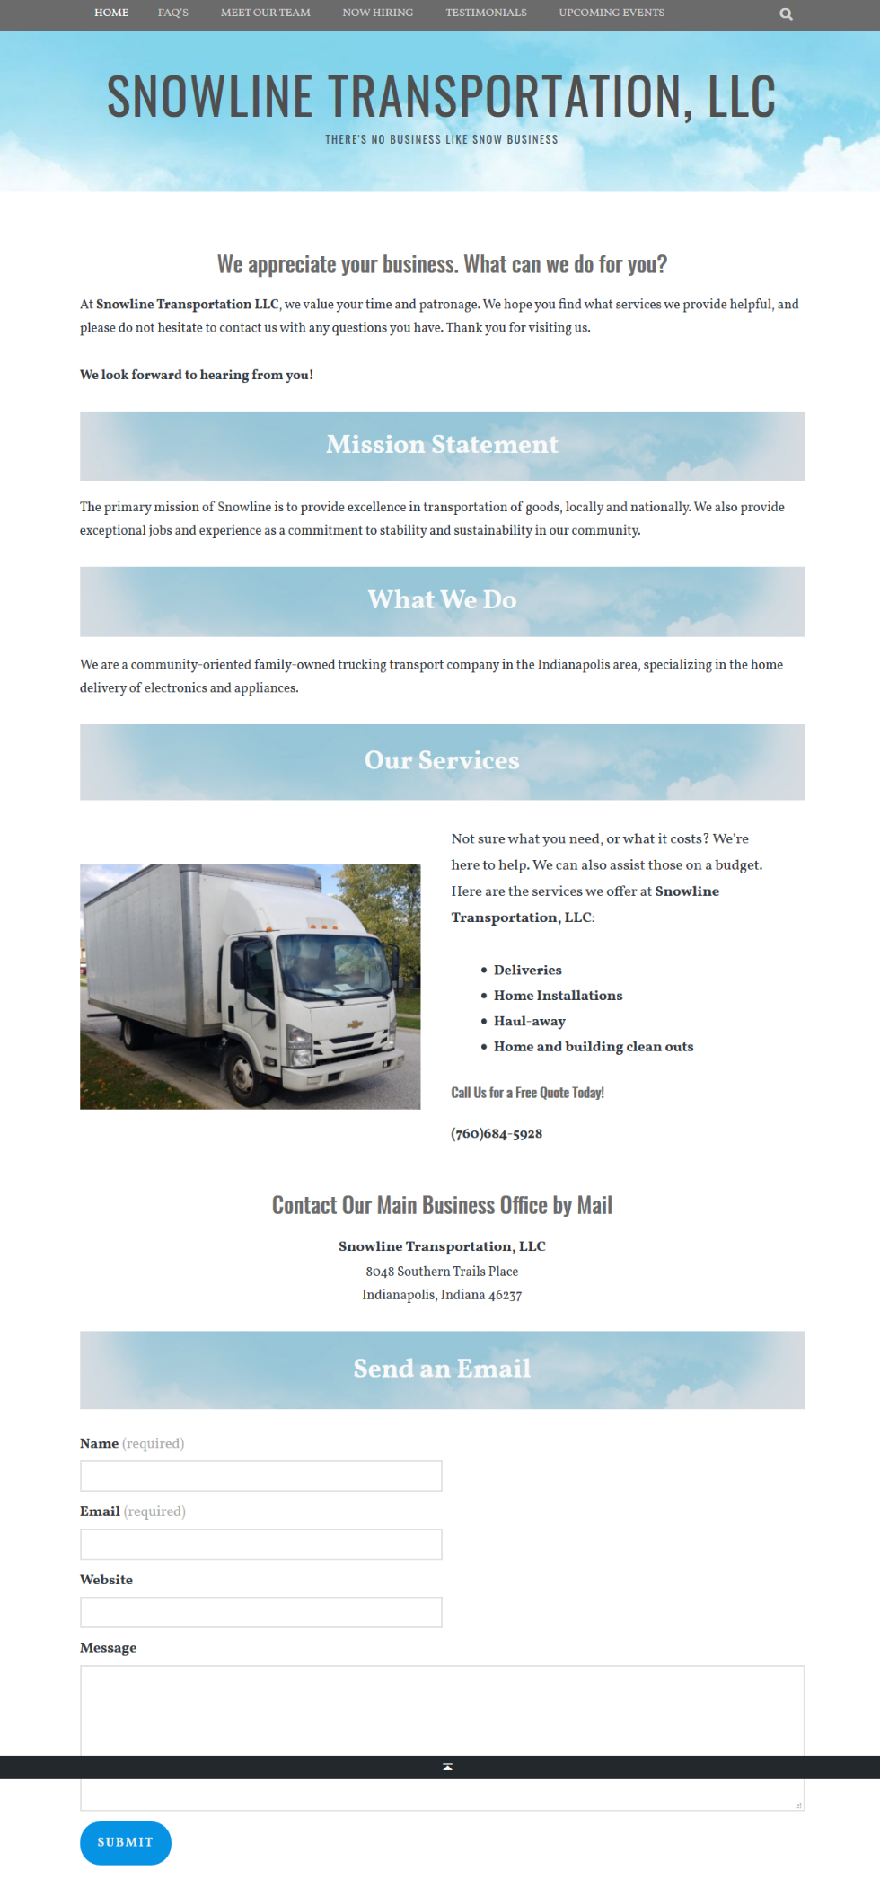

### **Results and Overall Effectiveness of the Usability Testing**

Over the course of the semester, I continuously learned how much time, care, and ongoing effort it takes in building a professional business website from scratch. I appreciated all of the positive comments along the way. Despite the various ups and downs I experienced with this ongoing project; I greatly enjoyed the challenge of the experience. The peer feedback I received via the usability testing allowed me to add further polish the website. Most of the comments were for minor fixes: such as spacing for the phone numbers, word choice changes, i.e.: “for hire” | changed to “to hire,” and a photo edit, (Vince).

Some suggestions I did not take – for example: the blue headers/banners placed on the **“home” page** (and other pages) were intentional, and *meant* to draw attention. One student noted them as a “distraction,” and was the only one to state this. All others I approached beforehand had stated otherwise. A close friend who I consulted frequently during the course of the design process was the one who made the initial suggestion, commenting: “the website looks nice, but it really needs a bit more color.” I also made it a point to put a spacer in between each blue banner, to give some leeway room, **as shown in the finalized screenshot below before usability testing**.

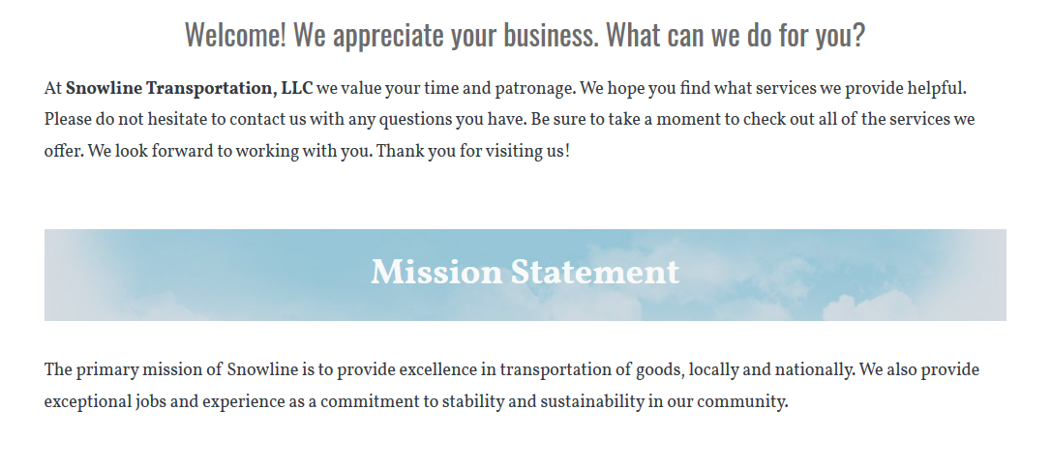

I also left the **“Upcoming Events”** page as is – as previously mentioned **on page 9**, I wanted site visitors to know about previous events in preparation for the possibility of checking them out the following year. If the information is not presented there, customers would not be aware. The top portion of the page can also easily be updated throughout the year to include new or current events, as well.

Other decisions were made based on design factors I felt would in the long run be more aesthetically pleasing, such as leaving the **“Meet Our Team”** photos where they were originally placed from the template. I shifted Derrhun’s image to the left, as suggested, but did not like how it looked – so I shifted it back. *Please also note*: the header at the top of the website works alphabetically, so any wording changes made to the separate page titles would also reflect on the main menu header. Again, the titles on the main menu were carefully chosen and deliberate. In conclusion, in presenting a polished and professional website for usability testing, I did not anticipate making any major changes. I fixed all of the minor issues that were presented, considered and tested the others, and contacted Artesia and Vince for further insight. My main goal in this website project was to give my clients (and friends), something they would be happy with, that was functional and well received. I am pleased to report that I feel I have done so. I take so much pride in my work.

I enjoyed sharing the website with others, and the majority reported that it looked like it had been created by a professional who got paid for their services, and I greatly appreciated the sentiment.